**Table of Contents – Master’s Writing course**

Computer pretest

1. Writing habits……………………………………………..…..3
2. Dictionary and reference use ………………………………4
3. Expanding vocabulary/ Parts of Speech…… ……………5
4. Plagiarism and writing an effective summary ……………6

Task 1 – Presentations (sign up)

1. Sentence structure ………… ………………………………..8
2. Structure and style of the academic article………………13
3. Wordiness: Style of the academic article........................13
4. Structure of the academic article ………………………...19
5. Introductions + Task 2 …………………………………… 20

Task 2 - Introductions

1. Nouns (count/non-count) and Noun compounds ………..26
2. Flow and paragraph structure ……………………………29
3. Methods ………………………………………………….…36
4. Parallel sentence structure ……………………………....37
5. Dangling Modifiers ………………………………….…….45
6. Results/Discussion - Body of the paper …………….…..48

Task 3 – Results/discussion

1. Writing emails, letters and CVs ……………………….... 49
2. Moves for abstracts …………………………………….…52
3. Tenses in research papers …………………………..… 53

Task 4 – Final post-task

1. Final exercises …………………………………………….57
2. What next? Tips to begin after you finish the course……60

**ACADEMIC WRITING**

**GOALS OF THE COURSE**

The course will focus on types of scientific professional writing such as found in journals and conference papers. Special emphasis will be placed on an analysis of the structure and content of academic articles. Various rhetorical techniques such as classification, comparison and contrast, description, summary writing, etc., will be covered. In addition, English syntax and grammatical difficulties particular to the non-native speaker will be drilled. The basics of formal English letter writing will also be addressed.

**STRUCTURE OF THE COURSE**

The sections meet once a week for a **two academic-hour lesson** at a fixed time during which general items will be discussed and presented. The first lesson of the course has a compulsory **pre-test**. The course will be a combination of lectures, exercises and workshop writing activities. Writing is an active process and requires active participation and practice.

In addition, each student will meet with the teacher during the semester in a **1:1 conference/tutorial session** to work on his/her own individual writing samples. Material used in the tutorial will be either the student's homework assignments or professional work-in-progress. These tutorial sessions will be set at a time convenient to both the teacher and the student.

**HOMEWORK**

In order to improve the ability to express oneself in a foreign language, practice and drill are crucial. Within the short time-frame of this course, this will be facilitated through a variety of assignments. These will be done either in class or as homework. Homework will be assigned at each lesson and all homework assignments are compulsory. Three compulsory writing tasks (to be handed in) and one presentation will be scheduled and announced on Moodle.

Pretest (in-class)

Task #1: Presentation task

Task #2: Introduction task

Task #3: Results/discussion task

Task #4: Final post-task

**ATTENDANCE**

Attendance is compulsory. If the need to miss a class arises (*e.g*., illness, unforeseen circumstances, reserve duty, conference), this must be coordinated with the teacher. Lateness (beyond once or twice) will be marked as ABSENT.

**MATERIALS**

1. A downloaded copy or laptop with the course material from MOODLE as assigned for EACH class.

2. Use of a good English-English dictionary and thesaurus.

3. A recent, example article from an academic journal in your field.

**Writing habits:**

1. What have you written in English? ________________________________________________________
2. How many papers have you written or co-written?

_________________

1. What do you do when you have writer’s block?

________________________________________________________

1. How do you organize your ideas before you start writing?

________________________________________________________

1. When and how do you revise your work? ________________________________________________________
2. How well do you write in English as opposed to your native language? ________________________________________________________
3. Do you write with a specific journal in mind? Which journals do you use?

_______________________________________________________

1. What role do other colleagues play in the writing process?

________________________________________________________

**Dictionary and reference use:**

**What reference material do you use while writing?**

**1 .________________________**

**2. ____________________________**

**3. __________________________**

**4. ___________________________**

**What should you be using?**

<http://www.oxforddictionaries.com/>

[www.usingenglish.com/reference/idioms](http://www.usingenglish.com/reference/idioms)

[www.dictionary.com](http://www.dictionary.com)

(see example entry ‘effect’)

[www.thesaurus.com](http://www.thesaurus.com)

(see example entry ‘good’ ‘bad’)

[www.ldoceonline.com](http://www.ldoceonline.com)

[www.learnersdictionary.com](http://www.learnersdictionary.com)

<http://scholar.google.co.il/>

**Pick one word that you use frequently and compare the results on a translation dictionary to an English-English dictionary:**

What do they both provide (give specific examples)

**1. ___________________________**

**2. ___________________________**

What are the differences?

**1. ___________________________**

**2. ___________________________**

**3. ___________________________**

**What functions do you use in searching for academic subjects?**

**1. ___________________________**

**2. ___________________________**

**3. ___________________________**

**Expanding vocabulary**

<http://www.englishvocabularyexercises.com/AWL/id21.htm>

* For each exercise, record a list of words which are difficult

<http://www.uefap.com/vocab/select/awl.htm>

**Parts of Speech**

|  |  |
| --- | --- |
| **Nouns** | identify, name persons, things, animals, places, states or qualities; some can take the plural.  Examples: **book, heat, strength, happiness** |
| **Pronouns** | are used as substitutes for nouns or noun phrases. Sometimes they replace whole clauses.  Examples: **he, they, it, this** |
| **Verbs** | express an action or a state. They are distinguished by having tense, voice (active passive), and aspect (the action is complete or in progress).  Examples: **talk, have eaten, were painted** |
| **Adjectives** | modify nouns by describing them, delimiting or specifying a quality.  Examples: a **happy** child, a **useful** device, a **valuable** ring |
| **Adverbs** | modify verbs, adjectives or other adverbs. They express relations of time, place, manner.  Examples: He runs **quickly**, They are **always** late for class, They performed **extremely** well. |
| **Prepositions** | express relationships of space, place, time, etc., between a noun and another part of the sentence.  Examples: **on, at, in, about** |
| **Conjunctions** | function as connectors between words, phrases, clauses or sentences.  Examples: **however, because, yet** |

**Plagiarism and writing an effective summary:**

When writing a piece in general, and in academics specifically, using people's ideas without giving credit is unacceptable and illegal. Taking other people's ideas in this fashion is considered 'plagiarism' and is often punishable by law.

Since other's people's ideas and research are an integral part of academic writing, care should be taken to use them properly.

Paraphrasing does not mean substituting a few words with synonyms (see example next page) nor does it mean using all of the sentences just by changing the order. Paraphrasing is a writing skill.

**Writing an effective summary:**

When writing a summary, it is wise to have a plan:

* The best way to start is to read the passage and write a sentence down in your own words **without looking at the original**.
* After writing, recheck your sentence to make sure it is accurate and that you remembered the important points you need.
* Next, it is a good idea to read the passage a few times while underlining **important/main ideas**, words, or examples.
* At this point you can continue writing your summary, being concise and constructing your own sentences.
* Use the main ideas you have made to construct sentences conveying the ideas you need, without using the original structure, or even order when possible.
* Revise your summary to make sure the information is accurate. Check to see if you have forgotten anything important and make sure it is **shorter than the original.**
* Finally, edit for grammar, spelling and punctuation.

**Writing article summaries**

* **FILE on moodle**

|  |
| --- |
| ***Writing task #1:*** plagiarism/ summary exercise – to be added on Moodle |

**Plagiarism exercise:** [**https://writing.wisc.edu/Handbook/QPA_paraphrase.html**](https://writing.wisc.edu/Handbook/QPA_paraphrase.html)

The Passage as It Appears in the Source

Critical care nurses function in a hierarchy of roles. In this open heart surgery unit, the nurse manager hires and fires the nursing personnel. The nurse manager does not directly care for patients but follows the progress of unusual or long-term patients. On each shift a nurse assumes the role of resource nurse. This person oversees the hour-by-hour functioning of the unit as a whole, such as considering expected admissions and discharges of patients, ascertaining that beds are available for patients in the operating room, and covering sick calls. Resource nurses also take a patient assignment. They are the most experienced of all the staff nurses. The nurse clinician has a separate job description and provides for quality of care by orienting new staff, developing unit policies, and providing direct support where needed, such as assisting in emergency situations. The clinical nurse specialist in this unit is mostly involved with formal teaching in orienting new staff. The nurse manager, nurse clinician, and clinical nurse specialist are the designated experts. They do not take patient assignments. The resource nurse is seen as both a caregiver and a resource to other caregivers. . . . Staff nurses have a hierarchy of seniority. . . . Staff nurses are assigned to patients to provide all their nursing care. (Chase, 1995, p. 156)

Plagiarism

Critical care nurses have a hierarchy of roles. The nurse manager hires and fires nurses. S/he does not directly care for patients but does follow unusual or long-term cases. On each shift a resource nurse attends to the functioning of the unit as a whole, such as making sure beds are available in the operating room, and also has a patient assignment. The nurse clinician orients new staff, develops policies, and provides support where needed. The clinical nurse specialist also orients new staff, mostly by formal teaching. The nurse manager, nurse clinician, and clinical nurse specialist, as the designated experts, do not take patient assignments. The resource nurse is not only a caregiver but a resource to the other caregivers. Within the staff nurses there is also a hierarchy of seniority. Their job is to give assigned patients all their nursing care.

## A Patchwork Paraphrase

Chase (1995) describes how nurses in a critical care unit function in a hierarchy that places designated experts at the top and the least senior staff nurses at the bottom. The experts — the nurse manager, nurse clinician, and clinical nurse specialist — are not involved directly in patient care. The staff nurses, in contrast, are assigned to patients and provide all their nursing care. Within the staff nurses is a hierarchy of seniority in which the most senior can become resource nurses: they are assigned a patient but also serve as a resource to other caregivers. The experts have administrative and teaching tasks such as selecting and orienting new staff, developing unit policies, and giving hands-on support where needed.

## A Legitimate Paraphrase

In her study of the roles of nurses in a critical care unit, Chase (1995) also found a hierarchy that distinguished the roles of experts and others. Just as the educational experts described above do not directly teach students, the experts in this unit do not directly attend to patients. That is the role of the staff nurses, who, like teachers, have their own “hierarchy of seniority” (p. 156). The roles of the experts include employing unit nurses and overseeing the care of special patients (nurse manager), teaching and otherwise integrating new personnel into the unit (clinical nurse specialist and nurse clinician), and policy-making (nurse clinician). In an intermediate position in the hierarchy is the resource nurse, a staff nurse with more experience than the others, who assumes direct care of patients as the other staff nurses do, but also takes on tasks to ensure the smooth operation of the entire facility.

**SENTENCE STRUCTURE**

Compound sentences

5

A **compound** sentence has **two or more independent clauses**.

Compound sentence

|  |  |
| --- | --- |
| Independent clause **+** | Independent clause |

*e.g. The bus stopped, and we got out.*

*I enjoy playing tennis, but I hate playing golf.*

*Learning a language is difficult ; however , it is worth the effort.*

In this type of sentence, each clause has **equal** (or nearly equal) **importance**. The clauses can be joined in **three** ways:

1. With a **coordinating conjunction**

*i.e. and, but, or, for, nor, yet, so*

*e.g. Diversity has become a strategic imperative for corporations, and the term has already entered the corporate vocabulary.*

or with a **correlative conjunction**

*e.g. not only ... but also*

*e.g. Not only have conservationists been successful in bringing issues to the attention of governments, but they have also achieved considerable success in having policies and institutions introduced or changed to meet their demand.*

1. With a **semi-colon (;)**

*e.g. Astute depositors could see what was happening to the value of the land that was supporting the assets of the banks; they moved quickly to remove their deposits for cash.*

1. With a **semi-colon** and another kind of **link word** called a **conjunctive adverb** *e.g.* furthermore, however, therefore, in contrast, similarly

*e.g. These obvious contamination problems have long been known;* ***however****, what is not often realized is the organic matter carried in ground water can contaminate samples.*

Many of these link words can also be placed in other parts of the sentence.

***However****, some other aspects of the reforms appear counterproductive. Some other aspects of the reforms,* ***however****, appear counterproductive. Some other aspects of the reforms appear counterproductive,* ***however****.*

Practice

6

*A. Underline the two independent clauses in the following sentences*

1. Modern management techniques have been used with success in firms in the industrial sector, and there is scope for a greater transfer of these concepts, techniques and principles to the farm sector.
2. We do not know where the first beachhead for the invasion was, but it is a fair guess that the narrow strait between Bali and Lombok was the first and most fundamental barrier to be breached.
3. Coal mining forms part of the relatively invisible history of Bannockburn, yet it was in some ways the backbone of the local economy.
4. Environmental politics may have a substantial policy focus to it, or it may be quite abstract and of little direct significance to policy.

*B. Join the following pairs of sentences together to make compound sentences.*

1. People have been conducting policy research for millennia. Policy studies emerged as a field of intellectual enquiry less than fifty years ago.
2. Problems do not just exist. They must be defined.
3. In the early 1870s there were large numbers of Chinese and European miners on the Bannockburn field**.** Their activities have proved difficult to trace in the physical remains in the landscape.

Complex sentences

A **complex** sentence has **one independent clause** and **one or more dependent clauses**.   
Complex sentence Complex sentence

***or***



Independent

Dependent Clause

Dependent Clause

**+** Clause Independent **+**

Clause

*e.g., Because she did not know e.g. She drove slowly because she*

*the route well, she drove slowly. did not know the route well*

In this type of sentence, the clauses do not have equal importance. The **independent (**or **main) clause** contains the most important idea, and the **dependent** clause adds extra information.

The two clauses are linked by a **subordinate conjunction** placed at the beginning of the dependent clause.

*e.g. although, because, just as, whereas, unless, even though*

*e.g. Today, New Zealand lacks crocodiles, goannas, freshwater turtles and land turtles, even though all were probably part of its Gondwanan heritage* 5

*Even though crocodiles, goannas, freshwater turtles and land turtles were probably part of its Gondwanan heritage, New Zealand lacks these species today.* 5Practice

*Underline the independent clauses and double underline the dependent clauses in the following sentences.*

1. Because it is so frequently misunderstood, the last point merits restatement.
2. One is restricted to a tiny patch of boulders and a rainforest relic on two islands, while the others are restricted to remnant areas on the North Island.
3. Although the [Lotto] win brought many nice things, it occasioned a period of transition that meant loss, change and much painful growth.
4. Some investors, who are known as **value investors,** invest in companies that have share prices close to or below the book value of the company

**Errors in Sentence Structure –** *Alyx Meltzer, Fall 2009*

[**http://www.hsc.edu.kw/VPO/ELU/EFLLAB/writing/e181/W3.%20Errors%20in%20Sentence%20Structure.pdf**](http://www.hsc.edu.kw/VPO/ELU/EFLLAB/writing/e181/W3.%20Errors%20in%20Sentence%20Structure.pdf)

*Students commonly make three kinds of sentence structure errors: fragments, run-ons, and comma splices*.

1. **Fragments:** Fragments are incomplete sentences. Very often, they consist of a subject without the predicate.

*Example:* The child who has a rash.

*Example:* Since the drugs have many side effects.

1. **Run-ons:** Run-ons are two independent clauses which are not joined in a grammatically correct manner.

*Example:* The doctor performed the operation the patient died.

1. **Comma splices:** Comma splices (CS) are two independent clauses that are joined by a comma, which is not a grammatically acceptable way to join independent clauses.

*Example:* The doctor performed the operation, the patient died.

**How to Correct Sentence Structure Errors**

*Each of these types of errors can be corrected so that the sentences become grammatically correct sentences.*

**Fragment:** The child who has a rash.

**Fix #1:** The child has a rash. *(remove “who”)*

**Fix #2:** The child who has a rash was just diagnosed with measles. *(add a predicate)*

**Fragment:** Since the drugs have many side effects.

**Fix #1:** The drugs have many side effects. *(remove “since”)*

**Fix #2:** Since the drugs have many side effects, the patient should be monitored. *(add a predicate*)

**Run-on:** The doctor performed the operation the patient died.

**Fix #1:** After the doctor performed the operation, the patient died. *(add a conjunction)* **Fix #2:** The doctor performed the operation; the patient died. *(join with a semi colon)* **Fix #3**: The doctor performed the operation. The patient died. *(create two sentences).*

**Comma Splice:** The doctor performed the operation, the patient died.

**Fix #1:** Although the doctor performed the operation, the patient died.*(add a conjunction)* **Fix #2:** The doctor performed the operation; the patient died. *(join with a semi colon)*

**Fix #3**: The doctor performed the operation. The patient died. *(create two sentences).*

**Exercise:** *Correcting Sentence Structure Errors – by Alyx Meltzer, Fall 2009*

*Directions:* Indicate if the sentence is A) correct B) a run-on C) a comma splice D) a fragment. **Then correct any errors.**

_____1. Ulcerative colitis is an inflammatory condition it affects part or all of the large intestine.

_____2. Ulcerative colitis, an inflammatory condition that affects part or all of the large

intestine.

_____3. Ulcerative colitis, an inflammatory condition, affects part or all of the large intestine.

_____4. Though frequent flare-ups are also common.

_____5. Fatigue and loss of appetite and/or weight, in addition to other symptoms that are not

directly colon-related, such as inflammation.

_____6. UC is generally diagnosed by sigmoidoscopy, colonoscopy, or barium enema.

_____7. While a colonoscopy permits examination of the entire colon.

_____8. The third commonly used test, the barium enema.

_____9. A number of options available for treatment.

_____ 10. A number of options available for treatment, these include steroids and

immunosuppressants.

_____11. Alternative mind/body treatments, such as biofeedback.

_____12. Biofeedback is helpful in addition massage may be used.

**Structure and style of the academic article**

**Style of the academic article**

1. Writing clearly and according to journal guidelines

Example #1 from *Nature* and *Science*  <http://www.nature.com/authors/author_resources/how_write.html?foxtrotcallback=true>

<http://www.sciencemag.org/site/feature/contribinfo/prep/res/style.xhtml>

1. **Conciseness and wordiness**

**Wordiness** --SUU Writing Center

Adapted from: http://www.suu.edu/hss/english/writingcenter/pdf/updated/tipsheet_wordiness.pdf **http://ceds.vu.edu.au/studentlearning/**

When writing, you should be extremely careful with the words, phrases, and clauses that you use. Even the smallest changes in wording or style can make a big difference in the strength of your prose.

**Wordiness**

* Using too many words is probably the most common mistake writers make as they begin to develop their academic voices.
* To avoid this problem, do not use “filler phrases” or “fluff” to try to stretch your papers to the desired length.
* Shorten or cut empty words and phrases.
* If you are in the difficult situation of having to lengthen a paper, either add another point to your thesis (one that you can fully develop) or expound on the points that you already have by adding detail and examples.

**Link (also on moodle):** eliminating wordiness: <http://ww2.usj.edu/PDF/cae/eliminatingwordiness.pd>

## Exercise : Eliminating Wordiness Exercise https://owl.english.purdue.edu/exercises/6/9/56

Revise these sentences to state their meaning in fewer words. Avoid passive voice, needless repetition, and wordy phrases and clauses. The first sentence has been done as an example.

1. Many local farmers plan to attend next Friday's meeting.

____________________________________________________________________________________________________________________________________________

1. Although Bradley Hall is regularly populated by students, close study of the building as a structure is seldom undertaken by them.

____________________________________________________________________________________________________________________________________________

1. He dropped out of school on account of the fact that it was necessary for him to help support his family.

____________________________________________________________________________________________________________________________________________

1. It is expected that the new schedule will be announced by the bus company within the next few days.

____________________________________________________________________________________________________________________________________________

1. There are many ways in which a student who is interested in meeting foreign students may come to know one.

____________________________________________________________________________________________________________________________________________

1. It is very unusual to find someone who has never told a deliberate lie on purpose.

____________________________________________________________________________________________________________________________________________

1. Trouble is caused when people disobey rules that have been established for the safety of all.

___________________________________________________________________________________________________________________________________________

1. A campus rally was attended by more than a thousand students. Five students were arrested by campus police for disorderly conduct, while several others are charged by campus administrators with organizing a public meeting without being issued a permit to do so.

____________________________________________________________________________________________________________________________________________

1. The subjects that are considered most important by students are those that have been shown to be useful to them after graduation.

____________________________________________________________________________________________________________________________________________

1. In the not too distant future, college freshmen must all become aware of the fact that there is a need for them to make contact with an academic adviser concerning the matter of a major.

____________________________________________________________________________________________________________________________________________

1. In our company there are wide-open opportunities for professional growth with a company that enjoys an enviable record for stability in the dynamic atmosphere of aerospace technology.

____________________________________________________________________________________________________________________________________________

1. Some people believe in capital punishment, while other people are against it; there are many opinions on this subject.

____________________________________________________________________________________________________________________________________________

## Exercise : Eliminating Wordiness Exercise 2

Directions: Combine each sentence group into one concise sentence.  
  
1. The cliff dropped to reefs seventy-five feet below. The reefs below the steep cliff were barely visible through the fog.

____________________________________________________________________________________________________________________________________________  
  
2. Their car is gassed up. It is ready for the long drive. The drive will take all night.

____________________________________________________________________________________________________________________________________________  
  
3. Sometimes Stan went running with Blanche. She was a good athlete. She was on the track team at school.  
____________________________________________________________________________________________________________________________________________

4. Taylor brought some candy back from Europe. It wasn't shaped like American candy. The candy tasted kind of strange to him.

____________________________________________________________________________________________________________________________________________

5. Government leaders like to mention the creation of new jobs. They claim that these new jobs indicate a strong economy. They don't mention that low-wage jobs without benefits and security have replaced many good jobs.

____________________________________________________________________________________________________________________________________________

**Structure of the academic article**

Use your example article or several articles which are typical of your field to answer the following questions:

Is the article divided into sections? _________

List the sections and their approximate percentage of the article:

|  |  |  |
| --- | --- | --- |
| Section heading | Percentage of the article | Purpose |
| 1 |  |  |
| 2 |  |  |
| 3 |  |  |
| 4 |  |  |
| 5 |  |  |
| 6 |  |  |
| 7 |  |  |

**Introductions**

A Model for Research Article  
Introductions from John Swales

**The 3 MOVES and STEPS of an Introduction in a Research Article described by Swales**

**Move 1- Establishing a territory**

**Step 1/2** – **Claiming Centrality** or **Making a topic generalization/statements about** **phenomenon**

* + Sets **boundaries** of present research.
  + Asks members of the community to accept that the research about to be reported is **significant** or within a **well-established research area**.

**Examples**:

*“Knowledge of xxx has great importance for…”*

*“Recently there has been wide interest in xxx.”*

*"The effect of X has been studied extensively…."*

*"X has received considerable attention…"*

*“There is now much evidence”*

*“A standard procedure for assessing has been…”*

*" The general features of …are well-known…"*

*"It is generally accepted that…"*

“*There are many situations which…”*

*“… is a common finding in patients with…”*

**Step 3 – Reviewing items of previous research**

* **This should not simply be a list of previous studies in sentence form, but include connections and insight/conclusions about the previous work in the field.**

**Move Two – Establishing a Niche**

*In most cases only one step of move 2 appears in introductions.*

**Move Two – Step 1 A - Establishing a Niche– Counter-claiming**

Author claims something that is in **contrast** with what others have found.

* Commonly opens with an adversative **sentence-connector**. –However, nevertheless, yet, unfortunately and but.
* Verbs like: Challenged, failed

***Example*** *–Others have found X; however, our research demonstrates….*

**Move 2 – Step 1B- Establishing the Niche- Indicating a gap**

When establishing a **gap** – Examples of language - “Previous work suffers from some limitations.”

Gaps are often signaled by verbs – **suffer or limited to** or adjectival phrases like **time consuming, expensive, not** **sufficiently accurate**.

**Move 2 - Step 1C – Question raising**

This step is common in life sciences and social sciences.

***Example****: It is important to ascertain what the behavior of this substance is when subjected to heat. The question remains…*

**Move 2 -Step 1D – Continuing a tradition**

Author’s work extends existing finding.

***Example:*** *Our research expands on previous studies that deal with…*

*Hence, additional studies are needed…*

***Note: following Move 2 should be a statement of the need/benefit of the research; e.g. Why fill this gap? Why ask/answer that question?***

***Move 2 can be cyclic***

*Niche establishment does not only occur at the end of a literature review, but may follow reviews of individual items, so that cycles of Move1/step3 and Move 2 recur.*

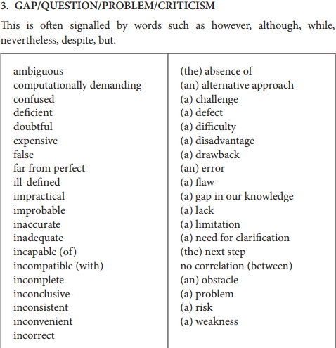

**Move 3 – Occupying the Niche**

*This is the move where the authors present their research.*

*Whenever Move 2 occurs, the ensuing Move 3 variously offers* ***to substantiate the******particular counter-claim*** *that has been made,* ***fill the******created gap****,* ***answer the specific questions*** *or follow the* ***established tradition****.*

***Step One is obligatory.***

**Step 1a- *Outlining the purposes or***

*In this step: The authors indicate their main purpose or purposes.*

*Ex. The main purpose of the present paper is to give…*

*The aim of the present study was…*

*The objective of the research was..*

***Step 1b- Announcing present research***

*The authors describe what they consider to be the main features of their*

*research.*

*Ex. This paper reports on the result obtained…*

*This paper evaluates…*

*This study focuses on…*

*We attempt to…*

In both steps the opening step is a **promissory** statement, and is typically marked by the **absence of references** to previous research and **the use of demonstrative** **references to the present text**.

**Move 3 –**

**Step 2 - Announcing principal findings**

*Step 2 follows step 1 with a summary announcement of principal findings.*

**Step 3 - Indicating research article structure.**

*Step 3 indicates in varying degrees of detail the structure, and occasionally, the content of the remainder of the RA. If step 3 occurs it is at the end of the introduction. Typical of computer science articles.*

(Steps 2 and 3 – existence of these steps is discipline related)

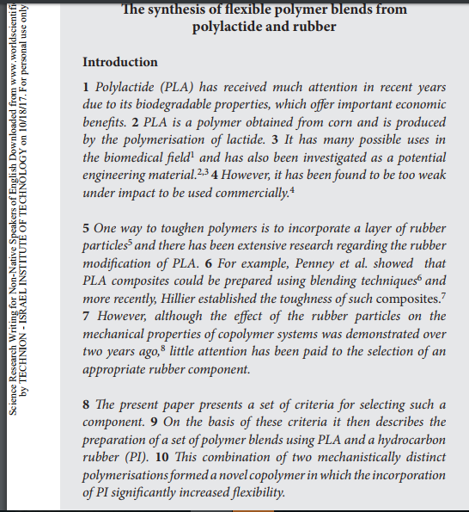

**from** Glasman-Deal, H. (2009). *Science research writing for non-native speakers of English*. World Scientific.

**Example Introduction – Swales Moves -** *fill in the moves*

Attitudinal Congruence and Similarity as Related to Interpersonal Evaluations in Manager-Subordinate Dyads

**Move ______**  
In recent years applied researchers have become increasingly interested in the interpersonal relationships with manger-subordinate dyads.

**Move _____ step ______**  
The majority of studies have focused on actual similarity between managers and their subordinates as related to managers’ appraisals of subordinates’ performance (Miles, 1964; Nieva, 1976; Ruda, 1970; Senger, 1971), subordinates’ job satisfaction (Huber, 1970), and subordinates’ evaluations of their managers (Weiss, 1977). A few studies have examined the extent to which subordinates congruently perceive their managers (referred to here as “subordinate’s perceptual congruence”). These studies suggest that subordinates who are more perceptually aware of their superiors’ work-related attitudes receive higher performance evaluations (Golmieh, 1974; Green, 1972; Kabivutzm 1972) and are more satisfied with their superiors (Howard, 1968).

**Move ______**

Each of these previous studies has researched only a part of this complex dyadic interpersonal relationship. First, none of the studies has examined the effects of a manager’s congruent perception of a subordinate’s work-related attitudes (i.e., “manager’s perceptual congruence”). Second, no studies can be found that directly compare the relative importance of actual similarity with that of perceptual congruence. Third, none of the previous studies has looked at interpersonal perception by the manager and by the subordinate simultaneously within the same dyad.

**Move _______**

The purpose of the present field investigation was to study both actual similarity and perceptual congruence and to examine them from the perspective of both the manager and the subordinate. The study investigated the relationships of these perceptual processes in two important organizational outcomes: subordinates’ satisfaction with work and supervision, and managers’ evaluations of subordinates’ job performance. Specifically, the study examined: (a) the relative magnitude of perceptual congruence and actual similarity with these two organizational outcomes; (b) whether the more congruently a subordinate perceives the manager (subordinate’s perceptual congruence), the more satisfied the subordinate will be; and (c) whether the more congruently a manager perceives the subordinate (manager’s perceptual congruence), the higher the subordinate’s performance will be evaluated.

TASK 1 - 5-minute presentation for a general scientific audience

Please sign up to present during one of the Tuesday classes (link on Moodle in announcements/emails). Your presentation should be about your current research, and designed to be understood by a general scientific audience. Your presentation should be accompanied by a few power point slides to illustrate your ideas. **All presentations must be uploaded to Moodle the day before the presentation**. For example presentations for a general scientific audience, see ‘previous winners’ on the sites: <https://www.ed.ac.uk/institute-academic-development/postgraduate/doctoral/3mt/about-3mt> and <https://www.library.cmu.edu/3MT>.

TASK 2 – Introduction

Please write a NEW introduction (300-500 words) to your thesis or an article. Please use all 3 moves and label them in the WORD file. Submit by Moodle ONLY. When writing and revising, review and improve your wordiness, vocabulary, sentence structure, and anything else we have learned in the course so far. Use your pretest to try and avoid previous mistakes.

**NOUNS**

**Count versus non-count nouns**

From Glasman-Deal p. 52-53: <http://ezlibrary.technion.ac.il/login?url=http://search.ebscohost.com/login.aspx?direct=true&db=cat03307a&AN=tech.002363481&lang=he&site=eds-live&scope=site>

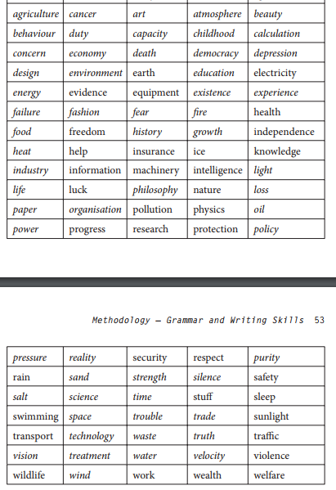

1. A/An/The

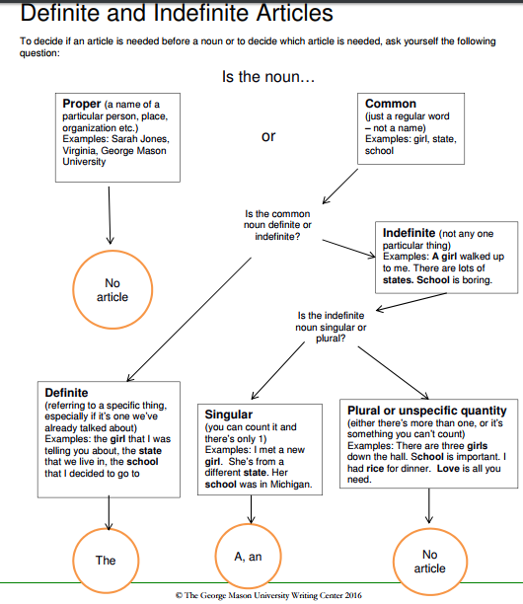

**Practice** [**http://s3.amazonaws.com/chssweb/documents/22779/original/DefiniteandIndefiniteArticles_2016.pdf**](http://s3.amazonaws.com/chssweb/documents/22779/original/DefiniteandIndefiniteArticles_2016.pdf)

Fill in the blanks with “a,” “an,” “the,” or nothing:

1. I need a book about ____ medicine.
2. ____ medicine I took relieved my cough.
3. ____ milk is sour.
4. Flowers bloom in ____ spring.
5. Please buy ____ milk.
6. I ordered ____ bottle of wine with dinner.
7. ____ spring is my favorite season.
8. ____ snakes swim in the creek.
9. ____ snake that I saw last night is still there.
10. ____ report that I finished yesterday is missing!
11. Did you write ____ report about interest rates that is on my desk?
12. She answered ____ phone in the kitchen.
13. She asked to borrow ____ phone from one of her friends.
14. Please point ____ camera away from the sun when you use it.
15. I would like ____ camera for my birthday.
16. ____ monkeys usually like to eat bananas.
17. The zookeeper fed ____ monkeys.
18. Would you like ____ pet monkey?
19. ____ money earned should not be wasted.
20. Did he pay you ____ money he owed you?
21. You could buy her ____ jewelry for her birthday.
22. I put ____ jewelry in the safe.
23. ____ fish tastes delicious when it is grilled.
24. Did you catch ____ fish that is in the bucket?
25. Some insects found in the tropics may carry ____ diseases.
26. 26, Did the doctor diagnose ____ disease she contracted?
27. Actually, she was diagnosed with ____ cancer, but it is curable.
28. ____ cancers that are caught early are usually treatable.
29. ____ beauty means different things to different people.
30. ____ beauty of summer is that the days are long and warm.
31. ____ research you did is good, but we need a lot more information

**Paragraph writing and flow**

Creating flow: example “Master plans:

1. **definition**
2. **compare**/**contrast**
3. **chronological** order (first, second third)
4. **process paragraph** involves a straightforward step-by-step description.
5. **qualification paragraph** acknowledges that what you previously asserted is not absolutely true or always applicable (example – limitations)
6. **analysis or classification paragraph** develops a topic by distinguishing its component parts and discussing each of these parts separately.
7. **Old-new information**
8. **Use linking words/connectors**
9. **Combination of several ‘plans’**

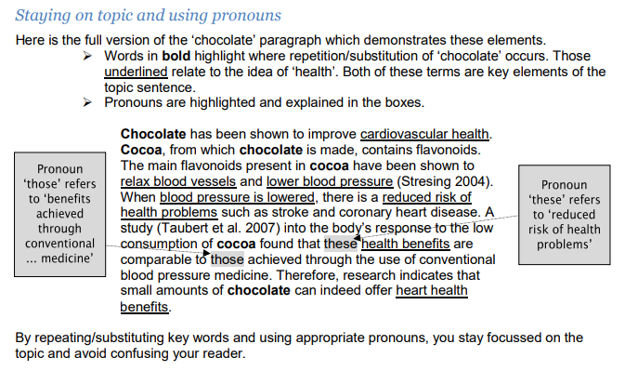

**Above From :** <https://www.adelaide.edu.au/writingcentre/docs/learningguide-paragraphwriting.pdf>

**Below From:** [**http://advice.writing.utoronto.ca/planning/paragraphs/**](http://advice.writing.utoronto.ca/planning/paragraphs/)

**Illustration** in a paragraph supports a general statement by means of examples, details, or relevant quotations (with your comments).

In Harry’s world fate works not only through powers and objects such as prophecies, the Sorting Hat, wands, and the Goblet of Fire, but also through people. Repeatedly, other characters decide Harry’s future for him, depriving him of freedom and choice. For example, before his eleventh birthday, the Dursleys control Harry’s life, keeping from him knowledge of his past and understanding of his identity (*Sorcerer’s* 49). In *Harry Potter and the Chamber of Secrets*, Dobby repeatedly assumes control over events by intercepting Ron’s and Hermione’s letters during the summer; by sealing the barrier to Platform 93/4, causing Harry to miss the Hogwarts Express; and by sending a Bludger after Harry in a Quidditch match, breaking his wrist. Yet again, in *Harry Potter and the Prisoner of Azkaban*, many adults intercede while attempting to protect Harry from perceived danger, as Snape observes: “Everyone from the Minister of Magic downward has been trying to keep famous Harry Potter safe from Sirius Black” (284). All these characters, as enactors of fate, unknowingly drive Harry toward his destiny by attempting to control or to direct his life, while themselves controlled and directed by fate. —Julia Pond, “A Story of the Exceptional: Fate and Free Will in the Harry Potter Series

The **definition paragraph** does exactly what you would expect: it defines a term, often by drawing distinctions between the term and other related ones. The definition that you provide will often be specific to your subject area. Try to avoid perfunctory dictionary definitions that do not inform your analysis in a meaningful way.

Our typology is built on three dimensions: internality, types of participants, and the degree of effective resistance. For our study, a civil war is any armed conflict that involves (a) military action internal to the metropole, (b) the active participation of the national government, and (c) effective resistance by both sides. With these criteria, we differentiate civil wars from other types of internal violent conflicts.

—Melvin Small and J. David Singer, *Resort to Arms: Int ernational and Civil Wars, 1816–1980*

The **analysis or classification paragraph** develops a topic by distinguishing its component parts and discussing each of these parts separately.

Policies of privatisation should be considered as responses to several distinct pressures. First, privatisation is a response by the state to internal forces such as increasing fiscal problems (O’Connor, 1973). It provides a means of lessening the state’s fiscal responsibilities by encouraging the development of private alternatives which, theoretically at least, do not draw upon the state’s financial reserves. Second, the promotion of private sector activity is a response to pressures originating ‘outside’ the state apparatus. These include demands from people who see a large state bureaucracy as inefficient and wasteful, demands from business interests who claim that they can overcome these inefficiencies, and pressures from client groups who seek to reduce their dependency on the welfare state by having more control over the services on which they depend. Clearly, this variety of calls for privatisation means that it is not a process with a uniform outcome; there exists a correspondingly wide variety of forms of privatisation.

—Adapted from Glenda Laws, “Privatisation and the Local Welfare State”

A **comparison or a contrast paragraph** zeroes in on a key similarity or difference between, for instance, two sources, positions, or ideas. Decide whether to deal only with similarities or only with differences, or to cover both. Also, keep in mind that a single comparison can be spread out over two separate paragraphs. As the following topic sentence indicates, you should make your intention clear to readers from the outset.

Evidence from industrialized countries suggests that compared with older men, older women more often experience functional impairments and activity limitations, have longer durations of disability, and spend proportionately more remaining years of life disabled.

—Kathryn M. Yount, “Differences in Disability among Older Women in Egypt and Tunisia”

A **qualification paragraph** acknowledges that what you previously asserted is not absolutely true or always applicable.

This study was a preliminary study of high school student value changes because of the terrorist attack on the U.S. The major limitations of this study were that the student population was from California and might not truly represent all high school students in the U.S. Further, this study could not be considered a truly longitudinal study because of privacy issues that prevented the researchers from identifying all the students who returned surveys before the attack. In addition, the senior class had graduated the previous year, and a much larger freshman class entered the school. These issues not only made the samples similar, but also different in their composition. The researchers will conduct periodic studies to explore whether these value changes are permanent and continue into adulthood. We do not know what if any changes will take place in their values as they grow older, and we will continue to explore their values in our longitudinal studies of the impact of the 9/11 terrorist attacks. [—Edward F. Murphy, et al., “9/11 Impact on Teenage Values]

The **process paragraph** involves a straightforward step-by-step description. Process description often follows a chronological sequence.

In brief, the mummification process may be summarized as follows: extract, sterilize, dehydrate, perfume, seal, tag, and stock. All were done ceremoniously and with due respect to the dead body. The viscera were extracted through an incision about 10 inches long, usually made in the left side of the abdomen. Through this incision, all the “floating” contents of the abdominal cavity, namely, the stomach, the liver, the spleen, and the intestines, were removed but the kidneys were left in place. The diaphragm was then cut and the thoracic contents removed through the abdominal incision. The heart, which was considered the center of emotions and the seat of conscience, was left in place. The ancient Egyptians seem to have attached no importance to the brain, which was removed through the ethmoid bone. Following these extractions began the slow process of sterilization and dehydration of the body, accomplished by osmosis with dry natron. Resterilization of the cavities, perfuming, closing the incision, and wrapping the body with linen and with beeswax completed the process. Molten resin was used to seal the body and its wrappings, providing a barrier against insects and anaerobes.

—Adapted from Mohame d E. Salem and Garabed Eknoyan, “The Kidney in Ancient Egyptian Medicine: Where Does it Stand?”

Very often, a single paragraph will develop by a **combination of methods**.

A celebrity is “known for being well-known” (Boorstin, 1961, p. 57), regardless of whether that eminence derives from the entertainment field, medicine, science, politics, religion, sports, or close association with other celebrities. Therefore, “fame” is a psychological concept akin to object-relations theory and is multifaceted in scope. The psychological study of celebrity and fame has generally followed three trends. First, there is an interest in characteristics that distinguish eminent people with significant skills or intelligence from the general population (Albert, 1996; Simonton, 1999). Other studies have addressed how celebrity affects public attitudes such as consumer behaviour (Till & Shimp, 1998; Tripp, Jensen, & Carlson, 1994). Lastly, there are psychological consequences of achieving fame. For instance, Schaller (1997) found that in some instances fame leads to chronic self-consciousness and perhaps self-destructive behaviour. This is an important aspect to the study of fame and celebrity given that other research has linked depressive neurosis to over-identification with social roles and norms, feeling dependent on others, self-esteem problems, and unfulfilled wishes of love and acceptance (Frommer et al., 1995). Indeed, Giles (2000) has described several problems faced by celebrities, including loneliness, making new friendships that are genuine, and the loss of privacy.

Definition

Analysis/

Classification

Illustration

—Lynn E . McCutcheon, et al., “Conceptualization and Measurement of Celebrity Worship Ó

***How long should a paragraph be?***

Paragraphs vary in length depending on the needs of the paragraph. Usually, paragraphs are between one-third and two-thirds of a page double spaced.

A series of long paragraphs can make prose dense and unpleasant to read. Check any paragraph that is a page or longer to see whether it would work better as two or more paragraphs. Break it at a logical place (e.g., where your focus shifts), and see whether you need to create new topic sentences to make the shift clear.

Also look out for short paragraphs only two or three sentences long. They make academic writing seem disjointed or skimpy. Try combining short paragraphs with the preceding or following paragraph if they share the same topic. Short paragraphs might also need to be developed further. Make sure that nothing vital has been omitted.

*Prepared by Margaret Procter, Writing Support, and Vikki Visvis, University College Writing Centre.   
Visit our many files offering advice about university writing at* [*www.advice.writing.utoronto.ca*](http://www.advice.writing.utoronto.ca)

See exercises

**INDEPENDENT LEARNING RESOURCES** © Learning Centre, The University of Sydney *This unit may be copied for individual student use*

**Exercise 1**

Read the following paragraph and decide whether it is well structured by analyzing whether its beginning sets out the structure for the rest of the paragraph. Put marks in the paragraph to show: i) the beginning

1. the sections of the middle
2. the end

*Over the past 30 years, research in the health arena has attracted psychologists, anthropologists and sociologists. The focus of psychological research in this area is concerned with individual motives, attitudes and beliefs in relation to both health and illness. Anthropological studies, however, are concerned with culture and health care. Such studies concentrate on a conception of disease as a cultural product and on the way social and cultural life in the past affect beliefs about health and illness. In sociological studies the emphasis is similar, but focused more on social relations within a particular social structure with respect to medical care.*

**Exercise 2**

Fill in the gaps in the following two paragraphs to highlight how the paragraph is structured:

*Poverty occurs when requirements for basic living are not met. Two types of poverty can be seen in the world today, absolute and relative.______ is generally restricted to the Third World where basic life essentials are lacking. These life essentials are food, fuel and shelter. The existence of________ is determined by comparison with the normal standard of living of a society. In Australian society, for example, relative poverty exists as shown in the statistics for child poverty. Both types of are problems for the government and people of the country.*

**Exercise 3**

Here is a paragraph from a student's essay in economics. However, the paragraph beginning has been omitted. Read the paragraph carefully, and then write a suitable beginning to the paragraph.

*The first GDP measurement is the 'income received method', whereby the income received by the owners of productive resources is found by adding the wages, rent, interest and profit earned at each stage of production. The second means of measurement, 'the production method' can be found using either the 'final product' or the 'value added', thus providing a figure for 'value of production'. The third measurement, the 'expenditure method' simply measures the amount spent buying finished goods.*

**Exercise 4**

The following text is a piece of student writing commenting on the political system of Pakistan. It is divided into seven sentences but they are in the wrong order. Read the sentences thoroughly to determine which one is the hyper-Theme and then which order the remaining sentences should be in.

*a) Another reason has been the lack of strong political parties.*

1. *While it is necessary to recognise that these are not the only factors determining the failure of a democratic system they stand as the most prominent reasons.*
2. *The first is that none of the leaders of the government, which has been based on a Western democratic constitutional system, has attempted to rule the country in a democratic way.*
3. *It can be argued that a Westerm political system has failed in Pakistan for two major reasons.*
4. *Instead they have instituted autocratic rule.*
5. *General Mirza (1980:19) claims that "Pakistan's illiterate people are neither interested nor competent in politics".*
6. *As a result, when constitutional crises have arisen there has not been sufficient popular support behind any one party to overcome the situation.*

**Exercise 5**

Read the following paragraphs which all come from essays or reports written by students. Identify problems with the paragraph by answering these questions:

Is the hyper-Theme stated clearly? Is there an apparent relationship between the hyper-Theme and the themes within the paragraph?

Has a focus been maintained? How could you go about improving the paragraphs?

1. *Nowadays ground water is polluted by industrial and agricultural works. Therefore, drinking tap water can lead to long term health problems. Further there is no guarantee regarding the safety and transportation of toxic chemicals and nuclear wastes. As a result, the potential for nuclear war is the major problem in the society.*

Problems:

*In economic terms underdeveloped countries or developing countries are defined as countries which have not yet reached that stage of economic development characterized by the growth of industrialization and level of national income sufficient to yield the consumption and domestic savings required to finance the investment necessary for further growth which is needed to cope with the demand of an increased population.*

**Methods**

Moves (Nwogu, 1997)

* Mostly appropriate for typical, empirical/experimental work
* Small percentage found also in environmental engineering and computer science

Move 4: Describing data-collection procedure:

1. Indicating source of data
2. Indicating data size
3. Indicating criteria for data collection

Move 5: Describing experimental procedures

1. Identification of main research apparatus
2. Recounting experimental process
3. Indicating criteria for success

Move 6: Describing data-analysis procedure

1. Defining terminologies
2. Indicating process of data classification
3. Identifying analytical instrument/procedure
4. Indicating modification to instrument/procedure

Writing style - Note use of:

* Noun compounds
* Technical terms
* Specific verbs
* More passive
* Sequencers

Parallel Structure

Adapted from:  copyright  2006, 2004  Margaret L. Benner  All rights reserved.

Sentence elements that are alike in function should also be alike in construction.  These elements should be in the same grammatical form so that they are **parallel**.

Here are some examples of parallel elements

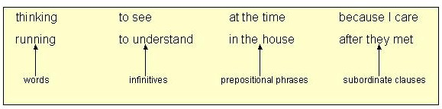

1.  With elements joined by  [coordinating conjunctions](https://webapps.towson.edu/ows/conjunctions.htm#COORDINATING CONJUNCTIONS), especially ***and, but,***and ***or***.

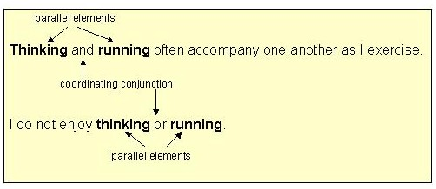

 Examples of parallel [**phrases**](https://webapps.towson.edu/ows/sentelmt.htm#Phrases)

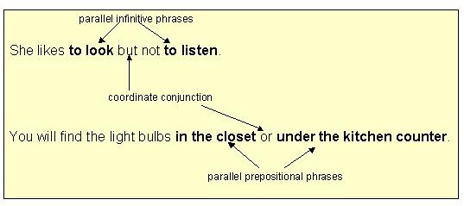

  Examples of parallel [**clauses**](https://webapps.towson.edu/ows/sentelmt.htm#Clauses)

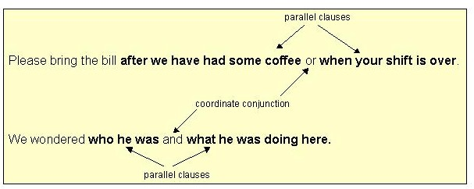

 Example #1

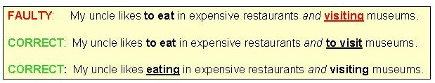

Example #2

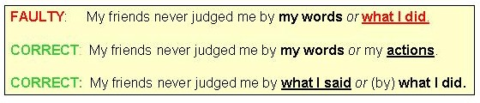

[Link to Exercise 1](https://webapps.towson.edu/ows/SelfTeachingUnits/Sentence%20Parallel%20Structure%20-%20Exercise01.aspx)

2.   Use parallel structure with elements in lists or in a [series](https://webapps.towson.edu/ows/comma.htm#In a Series).

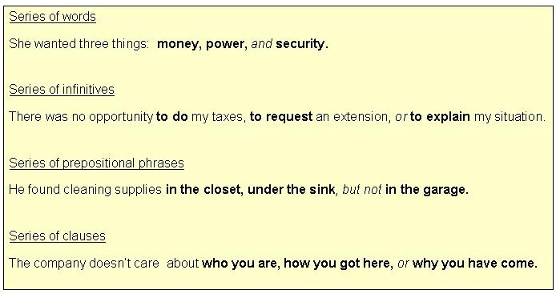

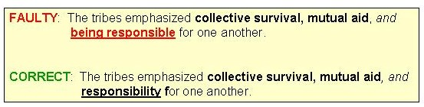

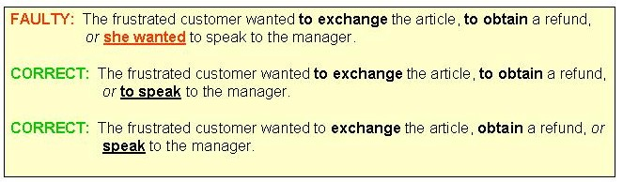

[Link to Exercise 2](https://webapps.towson.edu/ows/SelfTeachingUnits/Sentence%20Parallel%20Structure%20-%20Exercise02.aspx)

3. Use parallel structure with elements being compared.  (**X**is *more than / better than***Y**)

     When we compare things, we often use words such as *more, less, better,* and *worse,*  We connect the items being compared with words like *as* and *than.*

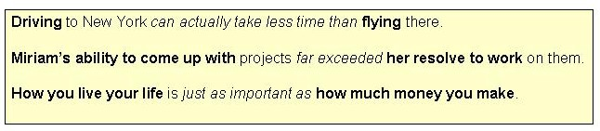

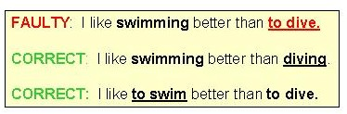

[Link to exercise 3](https://webapps.towson.edu/ows/SelfTeachingUnits/Sentence%20Parallel%20Structure%20-%20Exercise03.aspx).

4.   Use parallel structure with elements joined by a [linking verb](https://webapps.towson.edu/ows/verbs.htm#Linking verbs) or a [verb of being](https://webapps.towson.edu/ows/verbs.htm#Verbs of being).

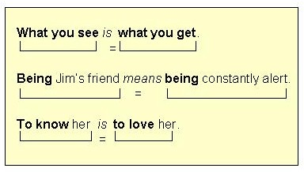

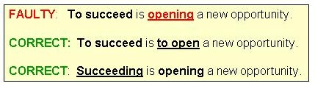

[Link to exercise 4.](https://webapps.towson.edu/ows/SelfTeachingUnits/Sentence%20Parallel%20Structure%20-%20Exercise04.aspx)

5.  Use parallel structure with elements joined by a [correlative conjunction](https://webapps.towson.edu/ows/conjunctions.htm#CORRELATIVE CONJUNCTIONS).

    These are the major correlative conjunctions:

**either / or           neither / nor           both / and        not only / but also**

Whatever grammatical structure follows one **must be parallel to** the grammatical structure that follows the other.

    Examples with ***either / or*** and ***neither / nor***

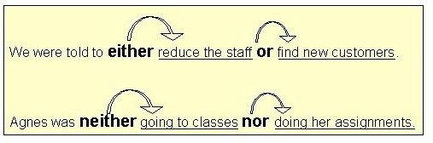

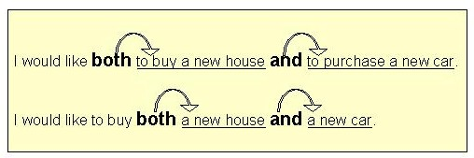

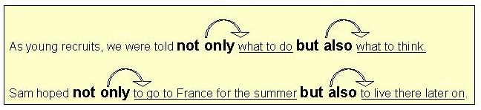

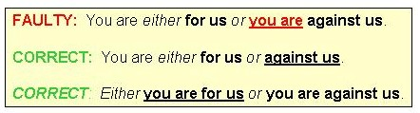

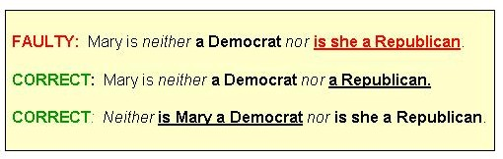

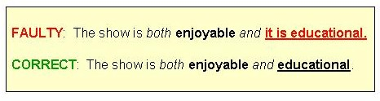

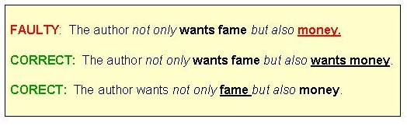

[Link to Exercise 5](https://webapps.towson.edu/ows/SelfTeachingUnits/Sentence%20Parallel%20Structure%20-%20Exercise05.aspx); [Link to post test.](https://webapps.towson.edu/ows/modulePARALLELposttest.htm)

**Parallelism exercise** <https://depts.gpc.edu/gpcltc/handouts/commquiz/Parallelism_Quiz.pdf>

**In the spaces provided, write the letter of the expression which is parallel with the first part of the sentence.**

_____ 1. Good driving is as much a matter of courtesy as (a) skill (b) of skill.

_____ 2. Jack is not only good-natured but (a) you can rely on him (b) reliable.

_____ 3. Our gymnasium is much smaller than (a) the gymnasiums in the schools around us (b) the schools around us.

_____ 4. Three things contributed to the team's defeat---illness, injuries, and (a)the weather was bad for football (b) bad weather.

_____ 5. Unless you like him very much, dating the same boy week after week may become as boring as (a) if you didn't have any dates at all (b) dating no one at all.

_____ 6. The land to the west of us is owned by the Double M Ranch, and (a) that to the north of us is owned by my uncle (b) my uncle owns the land to the north of us.

_____ 7. Working in a library appealed to me more than (a) to work in a laboratory (b) working in a laboratory.

_____ 8. Success in business requires the personality of a salesman, the persistence of a bulldog, and (a) imagination enough to predict the future (b) imagination of a prophet.

_____ 9. Concentrating on the musical score is difficult for the artist as well as (a) the conductor (b) conducting (c) for the conductor.

_____10. Diving from the deck of a ship requires more nerve than (a) to leap from a diving board into a pool (b) leap into a pool (c) leaping into a pool.

**The following sentences have faulty parallel structure. In the spaces provided, write them in correct parallel form.**

1. Walking and to swim are good exercise.
2. Pasted on almost every tree and pole, the posters were intended for political campaigning and to acquaint the voters with the candidate.
3. Drinking hot chocolate for breakfast appeals to me more than coffee.
4. Dot and I thought the bargains we found were better than our friends.
5. The team welcomed its hero with parades, speeches, and the streets were decorated.
6. The prisoners passed us with hanging heads, drooping shoulders, and their feet shuffled.
7. One day Carl suggested painting our sailboat and to start to practice for the race.
8. Gene scooped up the butter with his finger, tasted it, and making a face.
9. Mr. Wolfe was aware of Walt's lack of experience and that he was not yet ready for promotion.
10. He took up drinking, gambling, and killed several people.
11. To many students, being a success socially is more important than scholastic success.
12. He is an excellent tennis player because he is fast, accurate, and plays aggressively.
13. At the zoo the children saw a lion and bear.
14. My dad talks to me about being thrifty, saving money, and that I should plan a budget.

**Circle the letter that shows proper parallel structure.**

1. A) Exercising regularly and eating well are two things that I have trouble doing.

B) To exercise regularly and eating well are two things that I have trouble doing.

1. A) He is happiest at the chessboard, behind the wheel of a car, and on his boat.

B) He is happiest at the chessboard, when he is behind the wheel of a car, and on his boat.

1. A) Carlos has imagination, patience, and is perceptive.

B) Carlos is imaginative, patient, and perceptive.

1. A) Franklin and Eleanor Roosevelt had both talent and compassion.

B) Franklin and Eleanor Roosevelt both had talent and compassion.

1. A) The referee warned the team that either they must abide by the rules or he would stop the game.

B) The referee warned the team again that either they must abide by the rules or that he would stop the game.

1. A) The relay team had an early lead but then was lagging behind.

B) The relay team had an early lead but then lagged behind.

1. A) The explorer neither lost his confidence nor his enthusiasm.

B) The explorer lost neither his confidence nor his enthusiasm.

1. A) Chevrolet's new design is admired more for its appearance than for its performance.

B) Chevrolet's new design is admired more for its appearance than for how it performs.

**Dangling modifiers**

Another common mistake when using modifiers is having a dangling modifier. This occurs when the word that is being modified is not actually included in the sentence.

Dangling modifier examples <https://www.lynchburg.edu/academics/writing-center/wilmer-writing-center-online-writing-lab/grammar/misplaced-and-dangling-modifiers/>

1. **Incorrect**: Using the Pythagorean Theorem, the math problem was easily solved.  
   Did the math problem use the theorem? Who did?

**Correct**: Using the Pythagorean Theorem, Wendy easily solved the math problem. This version is correct because Wendy was the one who used the theorem.

1. **Incorrect**: Working through the night, the report was finished in time for class.  
   **Correct**: Working through the night, Jeremy finished the report in time for class.
2. **Incorrect**: Having finished the essay, a new Facebook status was uploaded.  
   **Correct**: Having finished the essay, Sandra uploaded a new Facebook status.

<http://www.apastyle.org/learn/faqs/dangling-modifiers.aspx>

1. **Incorrect:** Based on this assumption, I developed a model…   
   **Correct:** Based on this assumption, the model…   
   **Comment:** [The model, not I, was based on this assumption.]

Many dangling modifiers also result from the use of the passive voice. By writing in the active voice, you can avoid many dangling modifiers.

1. **Incorrect:** After separating the participants into groups, Group A was tested.   
   **Correct:** After separating the participants into groups, I tested Group A.   
   **Comment:** [I, not Group A, separated the participants into groups.]
2. **Incorrect:** The participants were tested using this procedure.   
   **Correct:** Using this procedure, I tested the participants.   
   **Comment:** [I, not the participants, used the procedure.]
3. **Incorrect:** To test this hypothesis, the participants were divided into two groups.   
   **Correct:** To test this hypothesis, we divided the participants into two groups.   
   **Comment:** [We, not the participants, tested the hypothesis.]

**Be especially careful of:**

* Focusing on
* Considering
* Using

**DANGLING vs. MISPLACED MODIFIERS**

**Dangling Modifiers** are words or phrases that do not have a clear term to modify in a sentence. Often, they can be found at the beginning of sentences, though they can also appear at a sentence’s end. They frequently include an –ing word (gerund) and to + verb (infinitive) phrase near the start of a sentence.

**Misplaced Modifiers** are words or phrases that do not clearly point to the word or phrase they modify, in this way obscuring meaning.

**Directions:** In the blank beside each sentence, indicate whether that sentence contains a dangling modifier (DM) or a misplaced modifier (MM). Then rewrite the sentence to correct it. Check the answers by using the key below. Because rewritten sentences will vary, have a writing counselor check your new sentences for you.

Examples:

1. At the age of six, my mother sang hymns to me. DM   
   **Correction**: When I was six, my mother sang hymns to me.
2. We were told at midnight the concert would begin. MM   
   **Correction**: We were told the concert would begin at midnight.
3. The car on the bridge which is green is mine.



1. Expecting confusion, our plans were made.
2. Feeling hot, sweaters were taken off.
3. I showed my dog to the veterinarian with the fleas.
4. Larry told me he was getting married that afternoon at night.
5. This typewriter is used by a secretary with a wide carriage.
6. Swimming out into the sea, the current grew stronger.
7. Walking along the bridge, a ship suddenly appeared.
8. The Honda was stalled on the road out of oil.
9. He kept a black book of all the girls he had dated in his desk.
10. On entering the room, the messages are easily seen.
11. While at the park, the sun shone brightly on the sunbathers.
12. Mary should jump at whatever is demanded quickly.
13. He kept all his medicine in the medicine cabinet that had been prescribed for him.
14. When only a baby, Mom took me scuba diving.

**Results/Discussion - Body of the paper:**

There are several sets of moves defined by the literature

1. **Organization – Decide on Logical Order for presentation:** *http://abacus.bates.edu/~ganderso/biology/resources/writing/HTWsections.html#results*

Possibilities

1. Most important results first
2. Simple results to more complex results
3. Chronological order, according to order methods applied

Maswana, S., Kanamaru, T., & Tajino, A. (2015). Move analysis of research articles across five engineering fields: What they share and what they do not. *Ampersand*, *2*, 1-11.‏

Move 7: Reporting results

Step 1: Restating data analysis procedures

Step 2: Restating research questions

Step 3: Stating general findings

Step 4: Stating specific findings

Move 8: Commenting on results

Step 1: Interpreting results

Step 2: Comparing results with previous studies

Step 3: Evaluating results (or research)

**Followed by discussion:**

Communicative moves in the discussion section of research articles, Matthew Peacock, System 30 (2002) 479–497.

**9 moves (Dudley-Evans):**

|  |
| --- |
| 1. information move (background about theory/research aims/methodology) |
| 2. statement of result (either a numerical value or reference to a graph or table) |
| 3. finding (same as statement of result, but without a reference to a graph or table) |
| 4. (un)expected outcome (a comment on whether the result is expected or not) |
| 5. reference to previous research |
| 6. explanation (reasons for unexpected results) |
| 7. claim (a generalization arising from the results: contribution to research) |
| 8. limitation |
| 9. recommendation (suggestions for future research) |

**Task 3: Results and discussion**

Please pick one table, graph, or figure and choose which moves you are going to incorporate to write about that table, graph, or figure. One paragraph should be results and one paragraph should be discussion, or both should be incorporated in 2 paragraphs that have flow and are coherent. You can choose a table, graph, or figure from your research but only mothing NEW that has not been written yet. All submissions are in a WORD file with MOVES marked in the margins and uploaded to Moodle. Please remember all of the rules of formal writing that we have learned: e.g. vocabulary, wordiness, sentence structure, punctuation, flow/connectors, sentence length, etc.

**Writing emails, letters and CVs**

Example letter for an academic job – see other examples at: <https://career.vt.edu/job-search/presenting_yourself/cover-letters.html>

[**email**]

November 14, 2011

Dear :

Paragraph 1- single spaced paragraph but 2 hits on the enter button between paragraphs.____ explain why you are writing (no RE:) in order to avoid keeping the reader in suspense. For example, you may start with sentences like, " in response to," " at the suggestion of my supervisor," or, "I am interested in finding a post doc position… " The following sentence is NOT "my name is…" but rather, "I am _____.

Paragraph 2- single spaced paragraph but 2 hits on the enter button between paragraphs.______ explain your research (PhD or most current) succinctly, focusing on the most important aspects. For example, describe how close the new work is to your department and what is so unique (procedure, apparatus, etc.). If your supervisor is well known use his/her name **with permission only.**

Paragraph 3- single spaced paragraph but 2 hits on the enter button between paragraphs.___ present how youcan contribute - include other qualifications that are relevant to the position- such as teaching or managerial experience. Since honors/ awards are included in your CV, put them in the cover letter only if they are very special. Stipends and other scholarship are also left for the CV. Same for publications: they are presented in the CV and only those in a very prestigious journal when then the name suffices may be added.

Paragraph 4- single spaced paragraph but 2 hits on the enter button between paragraphs closing where you thank the reader and offer to be contacted. Language like, "I am attaching my CV and can be contacted at…" or "I would be willing/happy …" Note here personal approach of 'you' and 'I' are acceptable._.

Sincerely,

Cc:

Encl:

**Writing emails:**

**Tips for writing polite and professional emails:**

1. Create a useful **subject line** that will inform your reader of the reason why you are writing. This is to avoid emails being ignored for fear of viruses or other unimportant mail.

2. Like in formal letters, **address the person as appropriately** as, "Dear Mr.____," "Dear Mrs. ____," "Dear Dr.______" etc. using correct spelling, punctuation and capitalization (do not use all caps- it looks like YOU ARE SCREAMING).

3. Write **short** emails that are to the point. Most professional people do not have the time to read lengthy emails.

4. Be **polite and use standard language conventions** (e.g. "I would like," "Could you…"). Sometimes expressions and other jokes do not translate well.

**Answering emails:**

5. When answering emails, make sure you answer in **a timely fashion** (depending on the situation and the expectations of the other party).

6. If an email has a series of questions **answers can be embedded**. Note this in your return email.

7. **Do not send private information** (e.g. passwords, gossip, etc).

8. **Send attachments** when including CV's or other document s for a job request (name them properly).

9. **Sign the email** with your full name (e.g. Sincerely, John Smith).

**Useful phrases:**

* I am writing to enquire about…
* I would like to know whether**…..**
* With regards to accommodation, do you only provide ….
* I would be grateful for any information you can give me and I look forward to hearing from you soon.
* With reference to your advertisement in yesterday's edition of The Times of Malta, I am interested in applying for …….
* I would be grateful if you would consider my application. I am available for interview any weekday afternoon and you can email me or telephone me on the number below.
* I am writing in connection with your advertisement for a….
* I am pleased to be able to inform you that we have...
* I am sorry to have to inform you that we ….
* I would be grateful if you could...
* I am sorry to hear about the problems you have been experiencing with the order you placed with us on the 23rd January. I cannot as yet say who is at fault but I assure you there will be a full investigation. Moyra Brown, who is our production assistant, will contact you shortly to arrange suitable compensation for the inconvenience that has been caused. I would like to apologise once more. Yours sincerely,
* <http://www.examplesof.com/education/writing_business_email_in_british_style.html>

**Writing a CV – example**

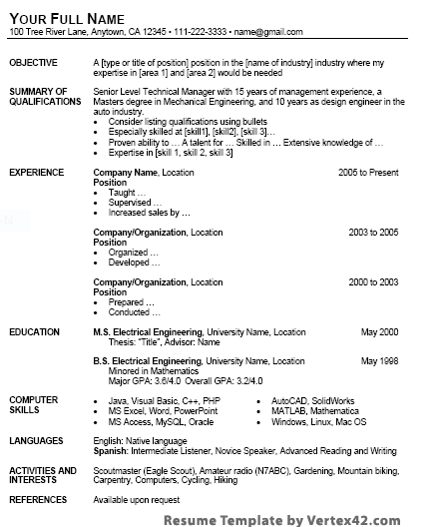

**Moves for abstracts:**

**Move 11: Stating purpose**

Step 1: What was done

Step 2: Overall aim

Step 3: Variables

**Move 12: Reporting what is known – referenced or not**

**Move 13: Stating a gap in knowledge**

**Move 14: Mentioning the method**

**Move 15: Reporting results**

Step 1: Interpreting results

**Move 16: Offering implications – theoretical or direct application**

1. Lewin and J. Fine. “The Writing of Research Texts: Genre Analysis and its Applications.” *Effective Teaching and Learning of Writing: Current Trends in Research*. Eds. Gert Rijlaarsdam, Huub van den Bergh and Michel Couzijn. Amsterdam: Amsterdam UP, 1996: 37-50.

**Tenses in research reports:**

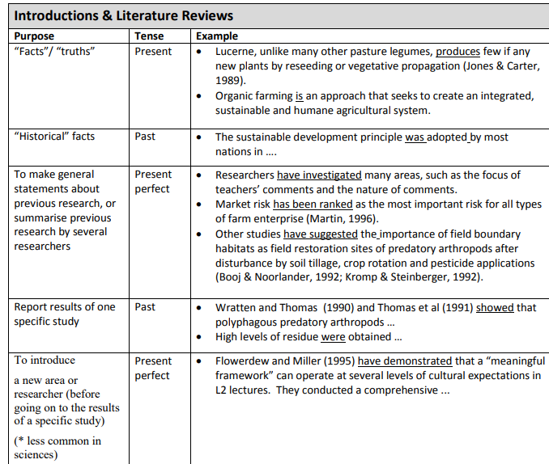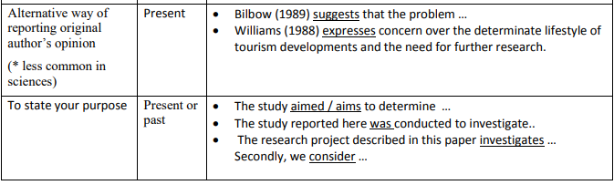

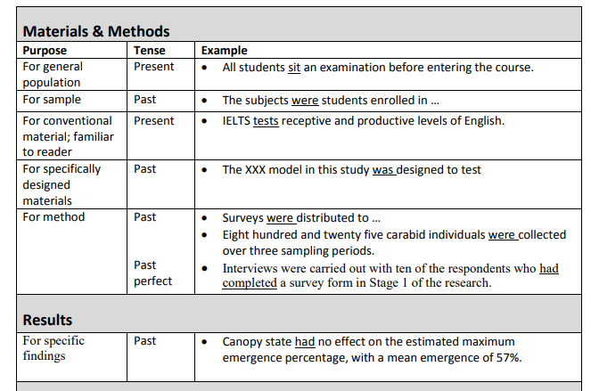

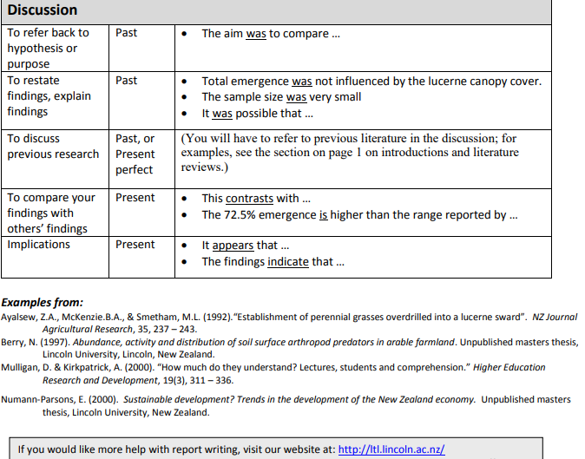

**Tenses exercise:**

**Delamination of FRP-reinforced concrete by means of an extended finite element formulation**

Put the verb in the correct tense (active or passive/present simple, past simple or present perfect). Note what kind of information you are reading in the sentence to determine the tense (ex. Fact, generalization, past work).

Strengthening of concrete beams and walls by means of fiber reinforced-polymer (FRP) plates or rods ________(be) a diffuse practice in civil engineering nowadays [1–5]. Accurate analysis of concrete blocks reinforced with externally bonded FRP plates ________(be) crucial. In particular, the stress transfer capability of the interface between the FRPplate and the structural element needs to be investigated thoroughly. According to the literature, the stress state of the interface is similar to that arising in a specimen in which an FRP plate __________(bond) to a concrete prism and subjected to tension [6]. At least five types of failure _______________(recognize): the rupture by decohesion inside the FRP, the adhesive or the concrete, or, alternatively, interfacial detachment either at the FRP/adhesive surface, or at the adhesive/concrete surface [7]. However, the most frequent type of failure __________(be) in the concrete at a depth of few millimeters from the adhesive layers [1,3]. As suggested in several guidelines for the design and construction of FRP-strengthened structures, the maximum transferrable load ______________(not increase) beyond an effective bond length [8,9,11,10]. In order to evaluate this maximum transferrable load, different approaches ________________(adopt) , such as, for instance, (i) stress analysis combined with linear elastic fracture mechanics for evaluating the critical delamination condition [12]; (ii) interface models where the FRP-adhesive-concrete cover is replaced by an equivalent non-linear one-dimensional bond stress– slip law [1,13,20,17]; (iii) finite element procedures based on Continuum Damage models, where failure ___________(result) from strain localization in a zone below the adhesive/concrete interface [14,16,15]. Nonetheless, it is well known that Continuum Damage models need to be regularized in order to obtain mesh independent results. This issue is generally tackled by means of non-local models, or, alternatively, smeared-crack models [16]. Interestingly, Benzarti et al. _____________________ (recently, present) a gradient damage model, where the evolution of the damage in the substrate is coupled with that of the adhesive layer [15]. In this way, the detachment of a concrete layer, whose thickness depends on the parameters governing the adhesive–substrate coupling, ___________________(can reproduce).

**Presentations: Here are some tips partially based on:** <http://www.garrreynolds.com/Presentation/prep.html>

1. **Start with the end in mind**

**Before you even open up PowerPoint**, sit down and really think about the day of your presentation. What is the real purpose of your talk? Why is it that you were ask to speak? What does the audience expect? In your opinion, what are the most important parts of your topic for the audience to take away from your presentation?

1. **Know your audience as well as possible**

**Who is the audience?** What are their backgrounds? How much background information about your topic can you assume they bring to the presentation?  
http://www.garrreynolds.com/Branding/images/orbul.gif**What is the purpose of the event?** Is it to inspire? Are they looking for concrete practical information? Do they want more concepts and theory rather than advice?  
http://www.garrreynolds.com/Branding/images/orbul.gif**Why were you asked to speak?** What are their expectations of you?

1. **Content, content, content**

No matter how great your delivery, or how professional and beautiful your supporting visuals, if your presentation is not based on solid content, you cannot succeed. Great content is a necessary condition, but not a sufficient one. But your presentation preparation starts with solid content (appropriate for your audience) which you then build into a winning story that you'll use to connect with your audience.

**A word of caution:** Though I am emphasizing how important content is, I also am begging you to spare your audience a "data dump"-- when a presenter crams too much information into the talk without making the effort to make the information or data applicable to the members of the audience. *A* data dump also occurs when data and information do not seem to build on the information that came earlier in the presentation.

1. **Keep it simple**

Simple can be hard for the presenter, but it will be appreciated by the audience. Simplicity takes more forethought and planning on your part because you have to think very hard about what to include and what can be left out.

Here's a simple exercise:

EXERCISE:If your audience could remember only three things about your presentation, what would you want it to be?  
  
(1)__________  
  
(2)__________  
  
(3)__________

1. **Outlining your content**

I suggest you start your planning in "analog mode." That is, rather than diving right into PowerPoint (or Keynote), the best presenters often scratch out their ideas and objectives with a pen and paper. Also, as I write down key points and assemble an outline and structure, I can draw quick ideas for visuals such as charts or photos that will later appear in the PowerPoint.

1. **Have a sound, clear structure**

Presentation structure is paramount. Without it, your wonderful style, delivery and great supporting visuals will fall flat. If you took the time in the first step to outline your ideas and set them up in a logical fashion, then your thinking should be very clear. You can visualize the logic of your content and the flow of the presentation. If your ideas are not clear first, it will be impossible to design the proper structure later when you create visuals and/or supporting documents. Your audience needs to see where you are going. And it is not enough to simply have an "agenda" or "road map" slide in the beginning that illustrates the organization of your talk. If you do not actually have a solid road of logic and structure, then an outline slide will be of no use. In fact, the audience may become even more irritated since you made the promise of organization in the beginning, but then failed to deliver the promise with a presentation which is muddled and lacks focus.

1. **So what?**

Surely you have been in an audience and wondered how what the presenter was talking about was relevant or supported his point. "So what?" you probably said to yourself. "So what?" — always be asking yourself this very important, simple question. If you can't really answer that question, then cut that bit of content out of your talk.

1. **The art of story telling**

Good presentations include stories. The best presenters illustrate their points with the use of stories, most often personal ones. The easiest way to explain complicated ideas is through examples or by sharing a story that underscores the point. Stories are easy to remember for your audience. If you want your audience to remember your content, then find a way to make it relevant and memorable to them. You should try to come up with good, short, interesting stories or examples to support your major points.

1. **Confidence — How to get it**

The more you are on top of your material the less nervous you will be. If you have taken the time to build the logical flow of your presentation, designed supporting materials that are professional and appropriate, there is much less to be nervous about. And, if you have then actually rehearsed with an actual computer and projector (assuming you are using slideware) several times, your nervousness will all but melt away. When you remove the unknown and reduce anxiety and nervousness, then confidence is something that will naturally take the place of your anxiety.

For other good tips see:

<http://www.adelaide.edu.au/english-for-uni/oral-presentation/>

<http://www.cs.berkeley.edu/~jrs/speaking.html>

http:// www.cs.utexas.edu/~dahlin/professional/goodTalk.pdf

**Final exercises**

**Appendix IV Passive to active in Methods; from Norris, C. B. (2009). Academic writing in English.**

Improve this Methods section by changing its 15 passive-voice verbs → active. Cut its length in half! Remember the essential exclusion line. Do you also have the skill to avoid many—or any?—“we” pronouns?

A retrospective review of all breast cancer patients treated for local recurrence in our hospital was performed. Cases with other cancers present or unknown primary were excluded. The information was gathered from the patient database of the Department of XXX, Turku University Central Hospital (TUCH), consisting of 5859 breast cancer patients. All the patient records in the database were reviewed, and those patients with local recurrence of breast cancer were selected to be included in this study. A total of 506 patients were found. They had been treated between 2005 and 2009 for local recurrence in the excision scar or for in-transit metastasis. Factors predicting outcome after local recurrence were analyzed. Patient records were analyzed for patient, tumor, and treatment characteristics. Details on tumor characteristics were obtained from pathology reports, and all pathology reports were re-examined by a specialist in pathology to obtain all information on the primary tumor. Surgical and radiological reports were analyzed for follow-up data on patterns and timing of local recurrence. Furthermore, possible development of lymph node or distant metastases was recorded. The ABCD staging system from 2003 was used for grouping patients according to their stage of the primary disease.

(15 passive verbs in 195 words)

**Appendices with Exercises\*** Appendix I **from** Norris, C. B. (2009). Academic writing in English.

Find more than 60 problems here

1. 35 females and 11 men of age over 90 years old were studied. It was shown by this study, that elderly can, despite of their old age, get improvements by participating a weight training program, etc.
2. Based on one criteria, informations indicate their equipments are the finest ones.
3. The aims include e.g.: 1) to control the patients for 1 year, 2) discovering noncompliance, 3) a search for ways to monitor patients compliance with doctors’ orders.
4. In 1994, in a survey in X province it was reported that the prevalence of diabetes was 3 % in the 30-60 years old age group (See the Table 7.). The prevalence rose up to 6 % in the age 30-60 population in 1997, as shown by the present study.
5. Eighty-seven per cent (131/150) of the patients, who had lymphoma diagnosed improved with this treatment after a period of sixteen weeks had past. The majority of them was male.
6. Also Aho’s 2007 results are more impressive compared to Bix’s findings (Bix 2001). Bix’s results are different to/than our study.
7. Her income was 70.000 € at a tax-rate of 48,5 % a rate she viewed as far too high.
8. On other hand, these two series contain remarkably interesting phenomenon, but on other hand resemble those of Smith, et al.’s whose so-called QRX series was published in 2009.
9. John Jones discusses about this data shortly in her third articles' result's chapter.
10. Other article soon will appear in the "Nature," It is now in print.
11. However, during the recession as much as every ninth nurse was remaining unemployed; studied hospital districts comprised of Helsinki, Lahti and Tampere.

**Exercise in Punctuation: from** Norris, C. B. (2009). Academic writing in English.

**All punctuation in this passage is absent, except for two full-stops (periods) after the two paragraphs. Punctuate it. In some locations, three or four options will each be suitable.**

Non-native English speakers find that rules governing the use of articles are particularly tough to negotiate in technical contexts a common error that an editor may encounter in medical papers is omission of articles before the names of body parts the rule is simple and easy to follow the definite article the should precede the names of body parts such as the heart or the lungs when the names of body parts are provided in a list however an article is necessary only after the first name such as in the heart lungs and brain. Appropriate capitalization for terms that have been derived from proper nouns is a controversial topic editors are unsure whether to capitalize Petri dish and Gram stain the popular rationale is that terms derived from proper nouns should be in lower case the adjectival form whereas terms should be capitalized for the proper noun itself thus Gram stain vs. gram positive bacteria and parkinsonian gait graafian follicle and luciferase we do capitalize Southern blotting the technique discovered by Edward Southern who was born ironically in northwest England northern and western blots are in lower case being based merely on the naming of the Southern blot.

Heavily adapted from “Common errors to look out for in medical papers,” Nikhil Pinto, European Science Editing, Vol. 39, No. 3, August 2013, p. 69.

**What next? *The writing process – Tips to begin***

|  |
| --- |
| 1. **Start with an outline of all the major headings and part of your article/ thesis. For example, for experimental work: IMRAD = Introduction, methods, results, discussion.** 2. **For the introduction: Try to create a flow chart of the main moves- what is the general topic, what has been done that leads up to your work – watching the flow from each stage to stage leading up to move 3; for literature: try to organize a list of citations and their main points - try to organize according to a plan.** 3. **For the methods: the most straightforward part: it is easiest to use an example article; usually includes: sample, setting, apparatus, procedure, analysis.** 4. **For the results: for articles, choose results that are most relevant to your research questions to include; organize results by table/figure; write a caption and text for each set of results.** 5. **For discussion: start by writing how results are usually compared to previous literature; write down the bigger picture- how the work contributes to the literature on the topic; write limitations of the research** |

|  |  |
| --- | --- |
| ***After you write a draft*** | |
| **Use a spell checker:** | They do not catch all mistakes. Some suggest looking at your paper backwards. |
| **Watch wordiness:** | Shorten all "which, that, who," prepositional phrases, and any redundant info (it, there) |
|  | Use specific vocabulary, specific verbs (e.g. not make, do, get, come, bring) and concise terms (e.g. Due to the fact that 🡪 because) |
| **Flow:** | Sentences should not be longer than 40 words. Use two sentences for more than 40 words. In general, sentences should have 1-3 ideas in 1-3 lines. |
|  | Watch flow. Each sentence/idea should be connected to that before/after. The same is true for paragraphs. Each paragraph should connect to the one before/after. |
|  | Make sure you have divided your work into paragraphs and that they are properly indented (TAB). |
| **Watch ‘confusables’:** | e.g. varying, various; effect, affect; continuous, continual, etc. |
| **Verbs:** | Use active voice. It's clearer and more concise than passive. |
|  | Use first person when possible (it saves the use of passive)- ex. We. |
|  | Double check tenses- remember which tenses are typical of each section of the article. |
| **Watch sentence structure:** | Avoid dangling participles: Using……, we……. |
|  | Watch parallelism in lists (look for sentences with ‘and’) |
|  | Check connectors and their corresponding punctuation, e.g. complex sentences with and, but, etc. |
| **Check your punctuation and proper capitalization:** | Commas, semicolons, colons, apostrophes, parentheses |
| **Nouns:** | Watch the "s" in the noun compounds- they should be dropped.  Ex. Cell line (not ‘’cells) |
|  | Check your articles- a,an (=for singular countable nouns only) and the. |
|  | Check non-count/count nouns you are unsure of. |
|  | Remember these are non-counts: Work//Research//Knowledge//equipment//evidence//advice |
| **Moves** | Use the moves to create an outline when writing each section of your paper/thesis |

Task 4 – Post-task