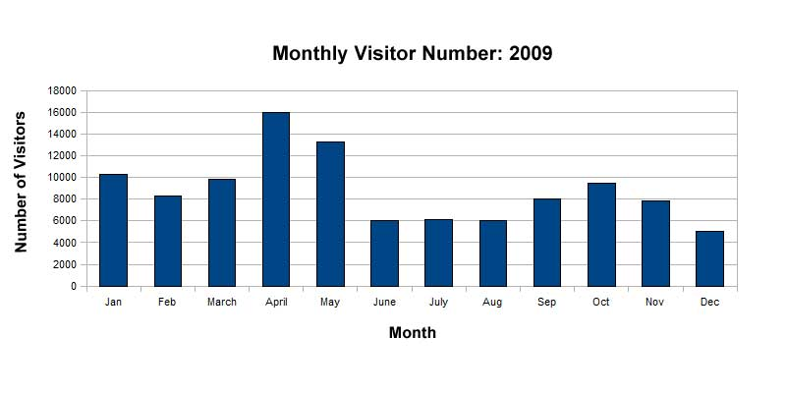

Use the following words to fill in the missing word according to the graph.

In some cases, there may be more than one correct answer.

**CLIMBED       FALL       BY       DROP       WENT UP**

**PLUMMETED       TO       EDGED UP       DIP       OF**

1. In February, the number of visitors declined          _____________________ 1,960.

2. In March, there was a rise in visitor numbers       _____________________ 1,519

3. In April, the number of visitors rocketed        _____________________ 16,000

|  |
| --- |
| 4. In May, there was a _____________________ of 2,711. |

5. In June, the number of visitors    _____________________ by 7,274.

|  |  |  |  |
| --- | --- | --- | --- |
| 6. In July, the number of visitors  _____________________ by 135. | | | |
| 7. In August, there was a _____________________ of 145 | | |
| 8. By September, the number of visitors _____________________ by 1,994. | |
| 9. In October, the number of visitors _____________________ by 1,511. |

10. In November, there was a _____________________ in the number of visitors of 1,692.     http://www.blairenglish.com/images/icons/blank.gif