# The 'Mozart effect' shown to reduce epileptic brain activity, new research reveals

# *Music by Mozart has been shown to have an anti-epileptic effect on the brain and may be a possible treatment to prevent epileptic seizures*

1. Listening to the famous 18th century composer's Sonata for Two Pianos K448 led to a 32% reduction in epileptiform discharges (EDs). These are electrical brain waves associated with epilepsy and can cause seizures or bursts of electrical activity that temporarily affect how the brain works.
2. A team led by Professor Ivan Rektor, from the Epilepsy Centre at the Hospital St Anne and CEITEC Masaryk University, Brno, Czech Republic, compared the effects of listening to Mozart's Sonata for Two Pianos K448 with Haydn's Symphony No 94. The effects on brain activity were measured by intracerebral electrodes that had been implanted in the brains of epilepsy patients prior to surgery.
3. "To our surprise, there were significant differences between the effects of listening to Mozart's K448 and Haydn's No 94", commented Professor Rektor. "Listening to Mozart led to a 32% decrease in EDs, but listening to Haydn's No 94 caused a 45% increase."
4. "In the second part of our study, we set out to explain the 'Mozart effect' in epilepsy", furthered Professor Rektor. The study found that men and women responded differently to the two pieces of music. Listening to Haydn's music led to suppressed epileptiform discharges only in women; in the men, there was an increase of epileptiform discharges. The acoustic properties, such as the rhythm, dynamics and tone, showed that the acoustic features of music composition have a different effect on men and women. "We believe the physical 'acoustic' features of the Mozart music affect brain oscillations - or brain waves - which is responsible for reducing EDs".
5. Researchers have previously hypothesised that the Mozart effect in epilepsy was connected to the emotional effects of music, as dopamine (the main neurotransmitters of the brain's reward system) is released when listening to music. Still, there is no direct proof of the mechanism. "We found that the reduction in EDs was larger in the lateral temporal lobe, the part of the brain which participates in translating acoustic signals, rather than in the mesiotemporal limbic region, which plays an important role in the emotional response to music."
6. "The effects of listening to music on epilepsy cannot be explained by the effect of dopamine released by the reward system", explained Professor Rektor. "Our patients were not music connoisseurs and said they were emotionally indifferent to the two pieces of music. There was, therefore, no reason to believe that K448 evoked more pleasure than No. 94."
7. Experts believe the study's findings could pave the way for individualised music therapies to be developed to prevent and control epileptic seizures in the future and have called for more research into the effects of music on the brain. Epilepsy affects 6 million people in Europe, and 15 million Europeans have one seizure at some time in their lives. "Based on our research, we suggest studying the use of musical pieces with well-defined acoustic properties as a non-invasive method to reduce epileptic activity in patients with epilepsy", concluded Professor Rektor.

**Exercises:**

1. **Define** the following terms according to the text:
2. dopamine
3. epileptiform discharges
4. lateral temporal lobe
5. mesiotemporal limbic region
6. **Summarize the details** of the study reported in the article. Cover in your answer the following factors: research questions/hypotheses, procedure (including sample size, duration, manipulation), results, and conclusions.

1. **Compare** the experimental and the control groups, referring to both similarities and differences. You may use some of the following expression:

similar            similarities              different             differences            in contrast

both although      unlike      while            like whereas differ

likewise on the other hand

4. In another study on the Mozart Effect, the researchers investigated the effect of Mozart music and white noise on memory performance with different task difficulty levels.

Look at the following chart and **describe the trends** it manifests.

**Introduce what the graph deals with** (the variables and the unit measures, and what each axis represents). Then **make up at least 3 sentences** to describe the trends it presents. Close your description with **a concluding sentence**, referring to the main trend/s shown in the graph.

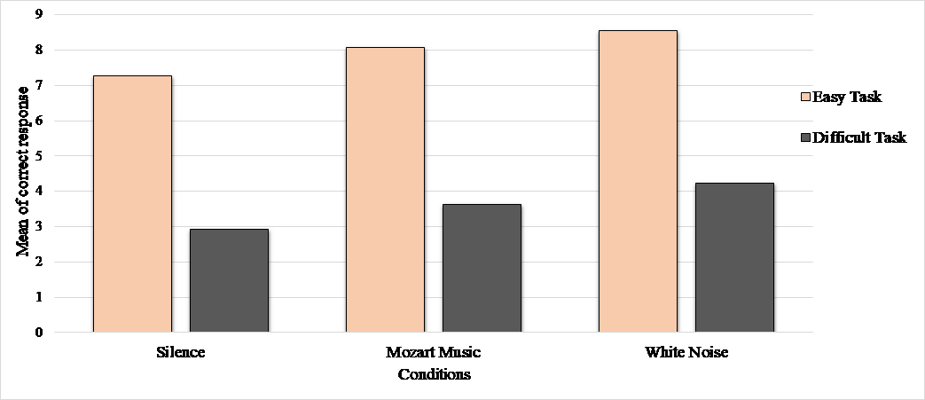

5. **Section E: Parts of Speech**

**Use suitable forms from the following chart to complete the sentences which follow.**

|  |  |  |  |
| --- | --- | --- | --- |
| **Verb** | **Noun** | **Adjective** | **Adverb** |
| Measure | Measurement | Measured |  |
| Reduce | Reduction | Reductive | Reductively |
| Increase | Increase | Increasing  Increased | Increasingly |
| Respond | Response | responsive | responsively |
| Affect | Effect | Effective | Effectively |
| Hypothesize | Hypothesis | Hypothetical | Hypothetically |
| prevent | Prevention | preventive |  |

1. The study showed that men’s and women’s _____________ to different pieces of music differed significantly.
2. The _____________ of the effects of music on the brain was conducted using electrodes.
3. An earlier _____________ regarding the Mozart effect focused on the emotional effects music possesses.
4. Given the results of the study, _____________treatment might be developed to ease epileptic patents’ lives.
5. The effects of listening to Mozart _____________ significantly from those of listening to Haydn.
6. The various listening conditions _____________ men and women differently.

**Section F: Grammar**

**Fill in the correct forms of the verbs in brackets.**

**Use the Present Simple and the Past Simple.**

**Both Active and Passive voices are needed.**

The Mozart effect _____________ (refer) to the theory that listening to the music of [Mozart](https://en.wikipedia.org/wiki/Mozart) may temporarily boost scores on one portion of an [IQ test](https://en.wikipedia.org/wiki/IQ_test). [Popular science](https://en.wikipedia.org/wiki/Popular_science) versions of the theory _____________ (claim) that "listening to Mozart _____________ (make) you smarter" or that early childhood exposure to classical music _____________ (have) a beneficial effect on [mental development](https://en.wikipedia.org/wiki/Development_of_the_nervous_system_in_humans).

The original study from 1993 _____________ (report) a short-term (lasting about 15 minutes) improvement on the performance of certain kinds of mental tasks which _____________ (know) as [spatial reasoning](https://en.wikipedia.org/wiki/Spatial_reasoning), such as [folding paper](https://en.wikipedia.org/wiki/Paper_folding) and solving [mazes](https://en.wikipedia.org/wiki/Mazes). The results _____________ (exaggerate) by the popular press and _____________ (become) "Mozart makes you smart", which _____________ (say) to apply to children in particular, while the original study _____________ (include) 36 college students.

These claims _____________ (lead) to a commercial [fad](https://en.wikipedia.org/wiki/Fad) with Mozart CDs being sold to parents. The U.S. state of [Georgia](https://en.wikipedia.org/wiki/Georgia_(U.S._state)) even _____________ (propose) a budget to provide every child with a CD of [classical music](https://en.wikipedia.org/wiki/Classical_music).

A [meta-analysis](https://en.wikipedia.org/wiki/Meta-analysis) of studies that have [replicated](https://en.wikipedia.org/wiki/Reproducibility) the original study shows that there _____________ (be) little evidence that listening to Mozart _____________ (have) any particular effect on spatial reasoning. The author of the original study _____________ (stress) shortly after its publication that listening to Mozart _____________ (have) no effect on [general intelligence](https://en.wikipedia.org/wiki/General_intelligence).