**Process Description - Exercise**

**Choose one type of process. Examine the diagrams and prepare a presentation to describe your chosen process.**

**Alternatively, you may choose a process you are undertaking in your research work.**

**Start with an introductory sentence, then describe the process step by step. Finish with a concluding sentence. Use appropriate logical connectors and the Passive Voice where needed.**

**======**

**Software development process:**

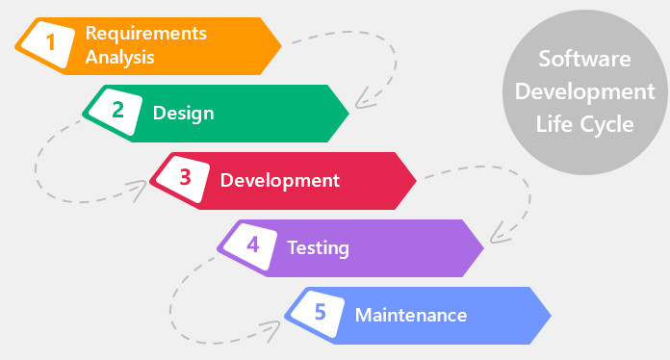

Software life cycle models describe phases of the software cycle and the order in which those phases are executed.

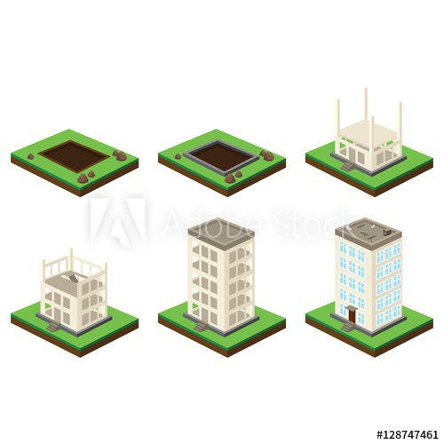

## Skyscraper Building Process:

## CREATING A CONCEPT AND DESIGN

## OBTAINING BUILDING PERMITS

## CLEARING AND EXCAVATING THE LAND

## POURING THE FOUNDATION

## COMPLETING THE FRAMING

## DOING ROUGH ELECTRICAL AND PLUMBING

## INSTALLING THE ROOF

## TAKING CARE OF HEATING AND COOLING NEEDS

## COMPLETING THE INTERIOR

## FINISHING UP

**Sleeping Process:**

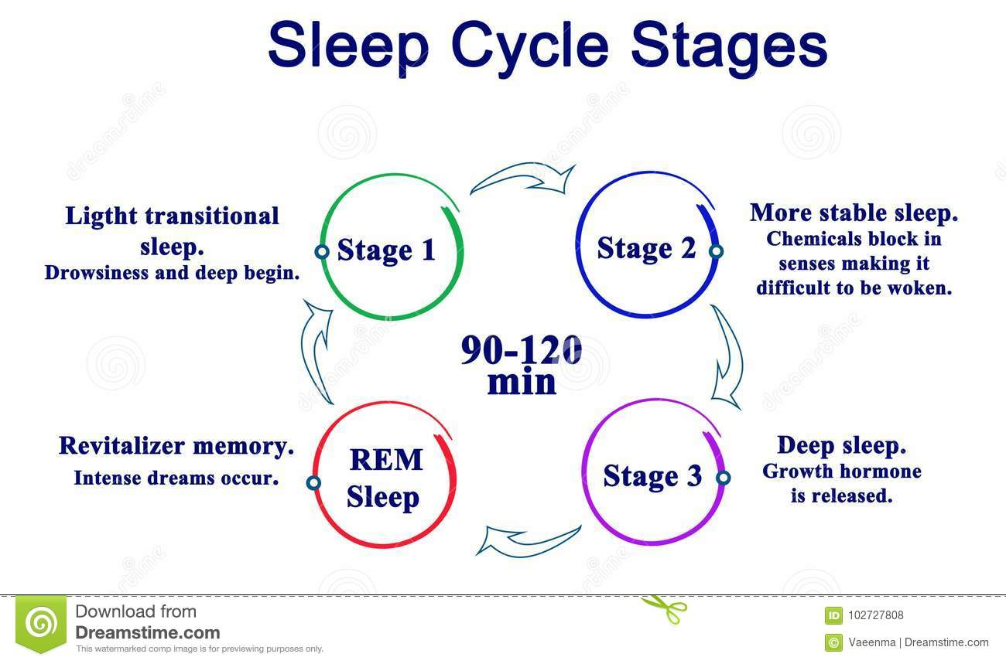

**Product development process:**

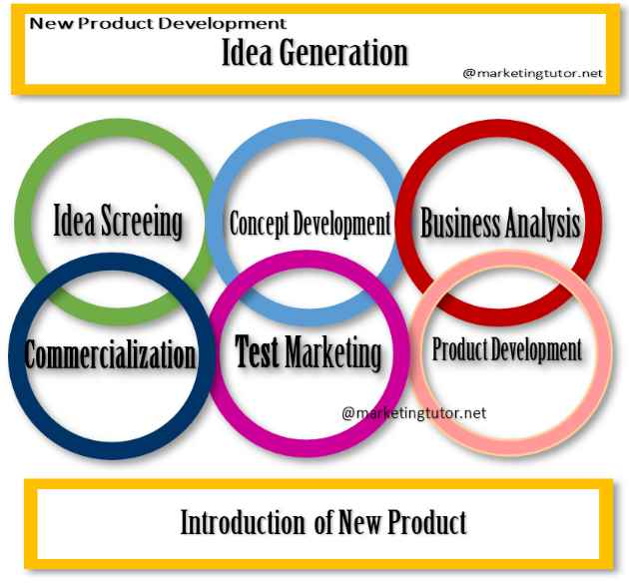

**The Engineering Process:**

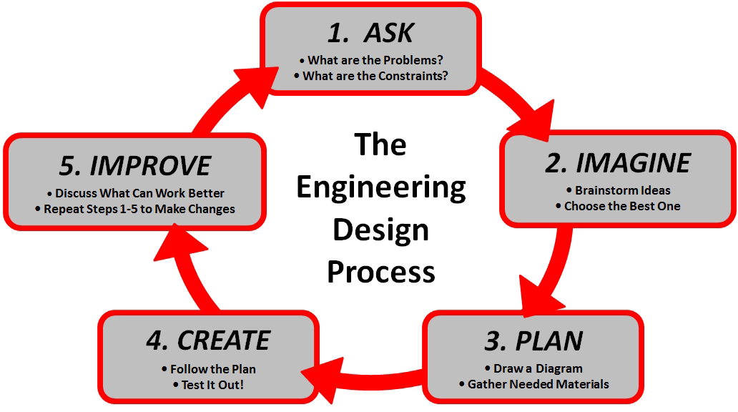

**The Writing Process:**

