**Expressing sequences in a process**

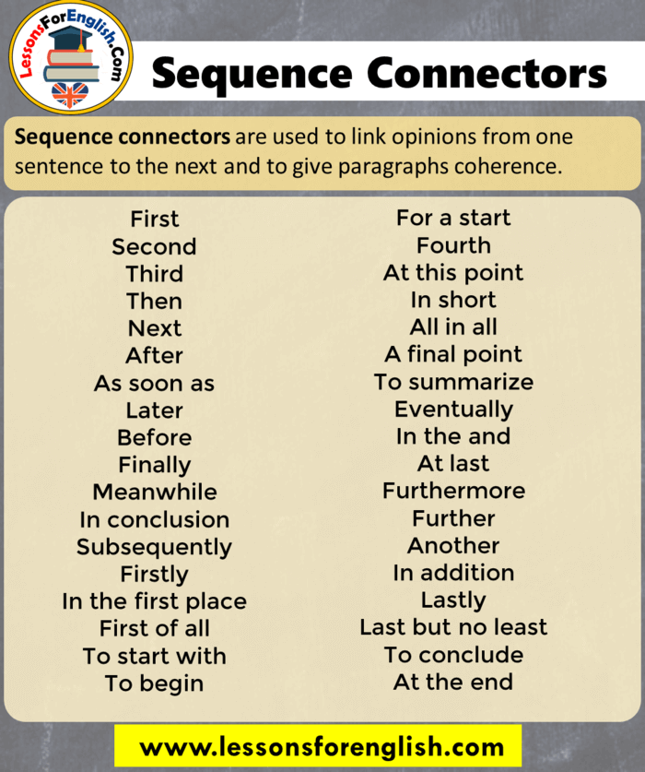

1. **Example: Describe the different stages of the construction of a residential building in a municipal area.**

*Planning and estimation – Having the plan approved by the municipality – Collecting building materials – Engaging masons and labourers – Construction work up to roofing – Fitting doors and windows – Plastering – Wiring – Colouring – Getting water connection – Sewerage connection*

**CONSTRUCTION OF A RESIDENTIAL BUILDING**

**First**, the planning and estimation for the construction of a residential building are done. Then, the plan has to be approved by the municipality. **After that**, the building materials are collected. **Next**, masons and labourers are engaged. **Thereafter**, the construction up to the roofing is completed. **Then** the doors and windows are fitted. **After that**, the inside and outside walls are plastered. **Next**, the wiring is done. The inside and outside walls are coloured. **After that**, water connection and sewerage connection are obtained. **Now**, the construction of a residential building is completed.

1. Exercise: Fill in suitable connectors to complete the process description.

**The Indian Air Force sometimes recruits airmen. Below is an outline of a selection procedure. Study it and describe the Process of selecting Air-Force candidates.**

Advertisement in the newspaper – Application – Written test held on (a) Mathematics (b) Language (c) General Knowledge – Appearance before an Interview Board – Medical Examination – Endurance Test – Selection – Appointment

**RECRUITMENT IN INDIAN AIR-FORCE**

Recruitment in the [Indian Air Force](https://en.wikipedia.org/wiki/Indian_Air_Force#:~:text=The%20Indian%20Air%20Force%20(IAF,aerial%20warfare%20during%20armed%20conflict.) is made through advertisements in the newspaper. ________________ applications are invited from suitable candidates. ________________ written tests on Mathematics, Language, and General Knowledge are held. ________________ the eligible candidates are called by registered letters to appear before an Interview Board. ________________ being duly interviewed the candidates have to go in for the medical examination. ________________, they have to appear at the endurance test too. ________________ , If they pass these tests, they are selected for appointment in the Air Force.